**throw keyword in Exception Handling**

* We can create exceptions explicitly. It is also used for User defined exception.
* To create an object of any exception type. We used throw.

**throw Program:**

**package** com.exception;

**import** java.io.IOException;

**public** **class** DemoThrow {

**public** **static** **void** main(String[] args) {

DemoThrow obj=**new** DemoThrow();

obj.display();

}

**void** display()

{

**try**{

**throw** **new** IOException("Explicit IOException created by user");

}

**catch**(IOException e){

System.***out***.println("Exception is "+e);

} } }

Output:

Exception is java.io.IOException: Explicit IOException created by user

**throws keyword in Exception Handling**

* throws keyword used when programmer know that method may cause exception, but method unable to handle exception that why programmer directly throws the exception.
* Throws keyword used with method declaration.

**throws Program:**

**package** com.exception;

**public** **class** DemoThrows {

**public** **static** **void** main(String[] args) **throws** Exception {

**int** x=5,y=0;

**int** c=x/y;

System.***out***.println("The result is="+c);

} }

Output:

Exception in thread "main" java.lang.ArithmeticException: / by zero

at com.exception.DemoThrows.main(DemoThrows.java:7)

**Topic: Inheritance**

**Definition:**

* One class derived from another one.
* One class acquires properties (Methods + Data Members) of another class called as Inheritance

**Inheritance in java** is a mechanism in which one object acquires all the properties and behaviors of parent object.

The idea behind inheritance in java is that you can create new classes that are built upon existing classes. When you inherit from an existing class, you can reuse methods and fields of parent class, and you can add new methods and fields also.

Inheritance represents the **IS-A relationship**, also known as *parent-child* relationship.

Why use inheritance in java

* For Method Overriding (so runtime polymorphism can be achieved).
* For Code Reusability.

**Syntax of Java Inheritance**

**class** Subclass-name **extends** Superclass-name

{

   //methods and fields

}

## Types of inheritance in java

On the basis of class, there can be three types of inheritance in java: single, multilevel and hierarchical.

In java programming, multiple and hybrid inheritance is supported through interface only. We will learn about interfaces later.

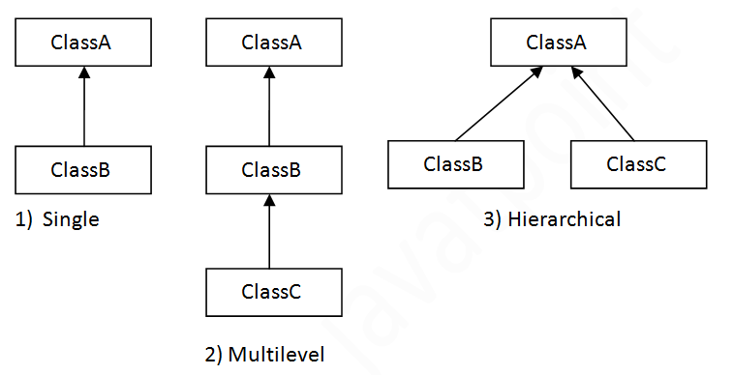

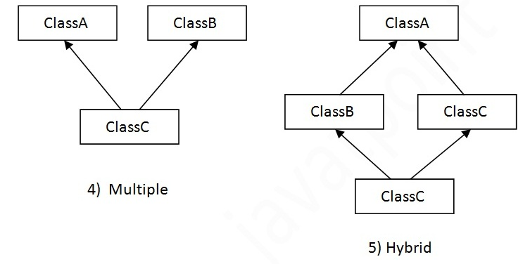

## Q) Why multiple inheritance is not supported in java?

To reduce the complexity and simplify the language, multiple inheritance is not supported in java.

Consider a scenario where A, B and C are three classes. The C class inherits A and B classes. If A and B classes have same method and you call it from child class object, there will be ambiguity to call method of A or B class.

Since compile time errors are better than runtime errors, java renders compile time error if you inherit 2 classes. So whether you have same method or different, there will be compile time error now.

Example:

**class** A{

**void** msg(){System.out.println("Hello");}

}

**class** B{

**void** msg(){System.out.println("Welcome");}

}

**class** C **extends** A,B{//suppose if it were

 Public Static **void** main(String args[]){

   C obj=**new** C();

   obj.msg();//Now which msg() method would be invoked?  Ambiguity.

}

}

# Method Overriding in Java

If subclass (child class) has the same method as declared in the parent class, it is known as **method overriding in java**.

In other words, If subclass provides the specific implementation of the method that has been provided by one of its parent class, it is known as method overriding.

Usage of Java Method Overriding

* Method overriding is used to provide specific implementation of a method that is already provided by its super class.
* Method overriding is used for runtime polymorphism

Rules for Java Method Overriding

1. method must have same name as in the parent class
2. method must have same parameter as in the parent class.
3. must be IS-A relationship (inheritance).

Program Method Overriding

**class** Vehicle{

**void** run(){System.out.println("Vehicle is running");}

}

**class** Bike2 **extends** Vehicle{

**void** run(){System.out.println("Bike is running safely");}

**public** **static** **void** main(String args[]){

Bike2 obj = **new** Bike2();

obj.run();

}

Output:Bike is running safely

Note:

static method cannot be overridden.

# Difference between method overloading and method overriding in java

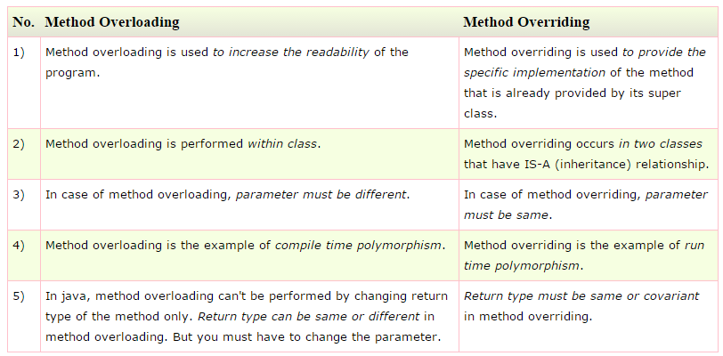

**Simple example of Inheritance**

class **Parent**

{

public void p1()

{

System.out.println("Parent method");

}

}

public class **Child** extends **Parent** {

public void c1()

{

System.out.println("Child method");

}

public static void main(String[] args)

{

Child cobj = new Child();

cobj.c1(); **//method of Child class**

cobj.p1(); **//method of Parent class**

}

}

**Output**

Child method

Parent method

**Multilevel Inheritance example program in Java**

Class X

{

public void methodX()

{

System.out.println("Class X method");

}

}

Class Y extends X

{

public void methodY()

{

System.out.println("class Y method");

}

}

Class Z extends Y

{

public void methodZ()

{

System.out.println("class Z method");

}

public static void main(String args[])

{

Z obj = new Z();

obj.methodX(); //calling grand parent class method

obj.methodY(); //calling parent class method

obj.methodZ(); //calling local method

}

}

# super keyword in java

The super keyword in java is a reference variable that is used to refer immediate parent class object.

Whenever you create the instance of subclass, an instance of parent class is created implicitly i.e. referred by superreference variable.

## Usage of java super Keyword

1. super is used to refer immediate parent class instance variable.
2. super() is used to invoke immediate parent class constructor.
3. super is used to invoke immediate parent class method.

## 1) super is used to refer immediate parent class instance variable.

***Problem without super keyword***

**class** Vehicle{

**int** speed=50;

}

**class** Bike3 **extends** Vehicle{

**int** speed=100;

**void** display(){

   System.out.println(speed);//will print speed of Bike

  }

**public** **static** **void** main(String args[]){

   Bike3 b=**new** Bike3();

   b.display();

}  }

Output:100

***Solution by super keyword***

//example of super keyword

**class** Vehicle{

**int** speed=50;

}

**class** Bike4 **extends** Vehicle{

**int** speed=100;

**void** display(){

   System.out.println(**super**.speed);//will print speed of Vehicle now

  }

**public** **static** **void** main(String args[]){

   Bike4 b=**new** Bike4();

   b.display();

   } }

Output:50

## 2) super is used to invoke parent class constructor.

|  |
| --- |
| The super keyword can also be used to invoke the parent class constructor as given below: |

**class** Vehicle{

  Vehicle(){System.out.println("Vehicle is created");}

}

**class** Bike5 **extends** Vehicle{

  Bike5(){

**super**();//will invoke parent class constructor

   System.out.println("Bike is created");

  }

**public** **static** **void** main(String args[]){

   Bike5 b=**new** Bike5();

}   }

Output:Vehicle is created

Bike is created

## 3) super can be used to invoke parent class method

|  |
| --- |
| The super keyword can also be used to invoke parent class method. It should be used in case subclass contains the same method as parent class as in the example given below: |

**class** Person{

**void** message(){System.out.println("welcome");}

}

**class** Student16 **extends** Person{

**void** message(){System.out.println("welcome to java");}

**void** display(){

message();//will invoke current class message() method

**super**.message();//will invoke parent class message() method

}

**public** **static** **void** main(String args[]){

Student16 s=**new** Student16();

s.display();

}

}

Output: welcome to java

welcome

**Note : Super class reference pointing to Sub class object.**

In context to above example where Class B extends class A.

A a=new B();

is legal syntax because of IS-A relationship is there between class A and Class B.

**Q. Can you use both this() and super() in a Constructor?**

NO, because both super() and this() must be first statement inside a constructor. Hence we cannot use them together.

# Final Keyword In Java

The **final keyword** in java is used to restrict the user. The java final keyword can be used in many context. Final can be:

1. variable
2. method
3. class

The final keyword can be applied with the variables, a final variable that have no value it is called blank final variable or uninitialized final variable. It can be initialized in the constructor only. The blank final variable can be static also which will be initialized in the static block only. We will have detailed learning of these. Let's first learn the basics of final keyword.

## 1) Java final variable

If you make any variable as final, you cannot change the value of final variable(It will be constant).

### Example of final variable

There is a final variable speedlimit, we are going to change the value of this variable, but It can't be changed because final variable once assigned a value can never be changed.

**class** Bike9{

**final** **int** speedlimit=90;//final variable

**void** run(){

  speedlimit=400;

 }

**public** **static** **void** main(String args[]){

 Bike9 obj=**new**  Bike9();

 obj.run();

 }

}//end of class

Output:Compile Time Error

## 2) Java final method

If you make any method as final, you cannot override it.

### Example of final method

**class** Bike{

**final** **void** run(){System.out.println("running");}

}

**class** Honda **extends** Bike{

**void** run(){System.out.println("running safely with 100kmph");}

**public** **static** **void** main(String args[]){

   Honda honda= **new** Honda();

   honda.run();

   }  }

Output:Compile Time Error

## 3) Java final class

If you make any class as final, you cannot extend it.

### Example of final class

**final** **class** Bike{}

**class** Honda1 **extends** Bike{

**void** run(){System.out.println("running safely with 100kmph");}

**public** **static** **void** main(String args[]){

  Honda1 honda= **new** Honda();

  honda.run();

  }

}

Output:Compile Time Error

### Q) Is final method inherited?

Ans) Yes, final method is inherited but you cannot override it. For Example:

**class** Bike{

**final** **void** run(){System.out.println("running...");}

}

**class** Honda2 **extends** Bike{

**public** **static** **void** main(String args[]){

**new** Honda2().run();

   }

}

Output:running...

**Que) Can we initialize blank final variable?**

Yes, but only in constructor. For example:

**class** Bike10{

**final** **int** speedlimit;//blank final variable

  Bike10(){

  speedlimit=70;

  System.out.println(speedlimit);

  }

**public** **static** **void** main(String args[]){

**new** Bike10();

 }

}

Output:70

Q) Can we declare a constructor final?

No, because constructor is never inherited.

# Abstract class in Java

A class that is declared with abstract keyword, is known as abstract class in java. It can have abstract and non-abstract methods (method with body).

### Abstraction in Java

**Abstraction** is a process of hiding the implementation details and showing only functionality to the user.

Another way, it shows only important things to the user and hides the internal details for example sending sms, you just type the text and send the message. You don't know the internal processing about the message delivery.

Abstraction lets you focus on what the object does instead of how it does it.

### Ways to achieve Abstaction

There are two ways to achieve abstraction in java

1. Abstract class (0 to 100%)
2. Interface (100%)

### Abstract class in Java

A class that is declared as abstract is known as **abstract class**. It needs to be extended and its method implemented. It cannot be instantiated.

### Example abstract class

1. **abstract** **class** A{}

### abstract method

|  |
| --- |
| A method that is declared as abstract and does not have implementation is known as abstract method. |

### Example abstract method

1. **abstract** **void** printStatus();//no body and abstract

### Example of abstract class that has abstract method

In this example, Bike the abstract class that contains only one abstract method run. It implementation is provided by the Honda class.

**abstract** **class** Bike{

**abstract** **void** run();

}

**class** Honda4 **extends** Bike{

**void** run(){System.out.println("running safely..");}

**public** **static** **void** main(String args[]){

 Bike obj = **new** Honda4();

 obj.run();

}   }

Output: running safely..

Example:

**abstract** **class** Shape{

**abstract** **void** draw();

}

//In real scenario, implementation is provided by others i.e. unknown by end user

**class** Rectangle **extends** Shape{

**void** draw(){System.out.println("drawing rectangle");}

}

**class** Circle1 **extends** Shape{

**void** draw(){System.out.println("drawing circle");}

}

//In real scenario, method is called by programmer or user

**class** TestAbstraction1{

**public** **static** **void** main(String args[]){

Shape s=**new** Circle1();//In real scenario, object is provided through method e.g. getShape() method

s.draw();

}  }

Output: drawing circle

### Abstract class having constructor, data member, methods etc.

An abstract class can have data member, abstract method, method body, constructor and even main() method.

//example of abstract class that have method body

**abstract** **class** Bike{

   Bike(){System.out.println("bike is created");}

**abstract** **void** run();

**void** changeGear(){System.out.println("gear changed");}

 }

**class** Honda **extends** Bike{

**void** run(){System.out.println("running safely..");}

 }

**class** TestAbstraction2{

**public** **static** **void** main(String args[]){

  Bike obj = **new** Honda();

  obj.run();

  obj.changeGear();

 }

}

Output: bike is created

running safely. gear changed

#### *Rule: If there is any abstract method in a class, that class must be abstract.*

1. **class** Bike12{
2. **abstract** **void** run();
3. }

Output: compile time error

#### *Rule: If you are extending any abstract class that have abstract method, you must either provide the implementation of the method or make this class abstract.*

**Topic: Interface**

An **interface in java** is a blueprint of a class. It has static constants and abstract methods only.

The interface in java is **a mechanism to achieve fully abstraction**. There can be only abstract methods in the java interface not method body. It is used to achieve fully abstraction and multiple inheritance in Java.

Java Interface also **represents IS-A relationship**.

It cannot be instantiated just like abstract class.

## Why use Java interface?

There are mainly three reasons to use interface. They are given below.

* It is used to achieve fully abstraction.
* By interface, we can support the functionality of multiple inheritance.
* It can be used to achieve loose coupling.

#### *The java compiler adds public and abstract keywords before the interface method and public, static and final keywords before data members.*

In other words, Interface fields are public, static and final by default, and methods are public and abstract.

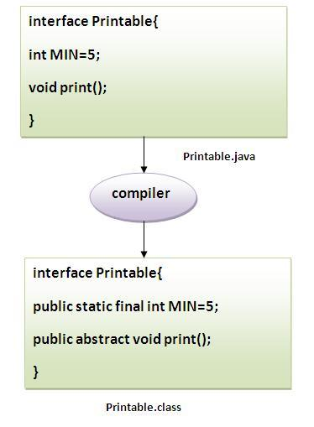

#### Understanding relationship between classes and interfaces

As shown in the figure given below, a class extends another class, an interface extends another interface but a **class implements an interface**.

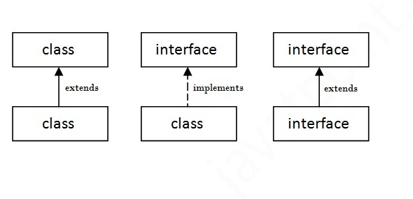

## Simple example of Java interface

|  |
| --- |
| In this example, Printable interface have only one method, its implementation is provided in the A class. |

**interface** printable{

**void** print();

}

**class** A6 **implements** printable{

**public** **void** print(){System.out.println("Hello");}

**public** **static** **void** main(String args[]){

A6 obj = **new** A6();

obj.print();

 }  }

Output:Hello

## Multiple inheritance in Java by interface

If a class implements multiple interfaces, or an interface extends multiple interfaces i.e. known as multiple inheritance.

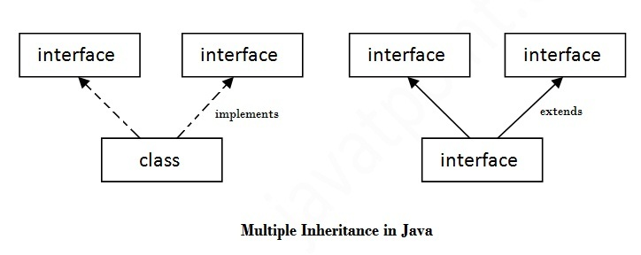

**interface** Printable{

**void** print();

}

**interface** Showable{

**void** show();

}

**class** A7 **implements** Printable,Showable{

**public** **void** print(){System.out.println("Hello");}

**public** **void** show(){System.out.println("Welcome");}

**public** **static** **void** main(String args[]){

A7 obj = **new** A7();

obj.print();

obj.show();

 }  }

Output:Hello

Welcome

## Q) Multiple inheritance is not supported through class in java but it is possible byinterface, why?

|  |
| --- |
| As we have explained in the inheritance chapter, multiple inheritance is not supported in case of class. But it is supported in case of interface because there is no ambiguity as implementation is provided by the implementation class. For example: |

**interface** Printable{

**void** print();

}

**interface** Showable{

**void** print();

}

**class** TestTnterface1 **implements** Printable,Showable{

**public** **void** print(){System.out.println("Hello");}

**public** **static** **void** main(String args[]){

TestTnterface1 obj = **new** TestTnterface1();

obj.print();

 }

}

Output: Hello

As you can see in the above example, Printable and Showable interface have same methods but its implementation is provided by class TestTnterface1, so there is no ambiguity.

## Interface inheritance

A class implements interface but one interface extends another interface .

**interface** Printable{

**void** print();

}

**interface** Showable **extends** Printable{

**void** show();

}

**class** Testinterface2 **implements** Showable{

**public** **void** print(){System.out.println("Hello");}

**public** **void** show(){System.out.println("Welcome");}

**public** **static** **void** main(String args[]){

Testinterface2 obj = **new** Testinterface2();

obj.print();

obj.show();

 }

}

Output: Hello

Welcome

## Q) What is marker or tagged interface?

An interface that have no member is known as marker or tagged interface. For example: Serializable, Cloneable, Remote etc. They are used to provide some essential information to the JVM so that JVM may perform some useful operation.

//How Serializable interface is written?

**public** **interface** Serializable{

}

Nested Interface in Java

Note: An interface can have another interface i.e. known as nested interface. We will learn it in detail in the nested classes chapter. For example:

1. **interface** printable{
2. **void** print();
3. **interface** MessagePrintable{
4. **void** msg();
5. }
6. }

# Difference between abstract class and interface

Abstract class and interface both are used to achieve abstraction where we can declare the abstract methods. Abstract class and interface both can't be instantiated.

But there are many differences between abstract class and interface that are given below.

|  |  |
| --- | --- |
| **Abstract class** | **Interface** |
| 1) Abstract class can **have abstract and non-abstract**methods. | Interface can have **only abstract** methods. |
| 2) Abstract class **doesn't support multiple inheritance**. | Interface **supports multiple inheritance**. |
| 3) Abstract class **can have final, non-final, static and non-static variables**. | Interface has **only static and final variables**. |
| 4) Abstract class **can have static methods, main method and constructor**. | Interface **can't have static methods, main method or constructor**. |
| 5) Abstract class **can provide the implementation of interface**. | Interface **can't provide the implementation of abstract class**. |
| 6) The **abstract keyword** is used to declare abstract class. | The **interface keyword** is used to declare interface. |
| 7) **Example:** public abstract class Shape{ public abstract void draw(); } | **Example:** public interface Drawable{ void draw(); } |

Simply, abstract class achieves partial abstraction (0 to 100%) whereas interface achieves fully abstraction (100%).

### Example of abstract class and interface in Java

//Creating interface that has 4 methods

**interface** A{

**void** a();//bydefault, public and abstract

**void** b();

**void** c();

**void** d();

}

//Creating abstract class that provides the implementation of one method of A interface

**abstract** **class** B **implements** A{

**public** **void** c(){System.out.println("I am C");}

}

//Creating subclass of abstract class, now we need to provide the implementation of rest of the methods

**class** M **extends** B{

**public** **void** a(){System.out.println("I am a");}

**public** **void** b(){System.out.println("I am b");}

**public** **void** d(){System.out.println("I am d");}

}

  //Creating a test class that calls the methods of A interface

**class** Test5{

**public** **static** **void** main(String args[]){

A a=**new** M();

a.a();

a.b();

a.c();

a.d();  }}

Output:

I am a

I am b

I am c

I am d